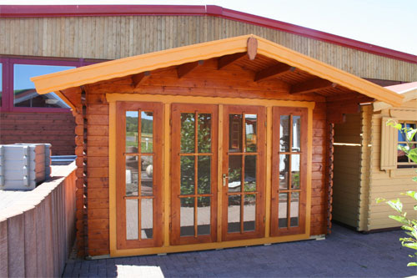 | 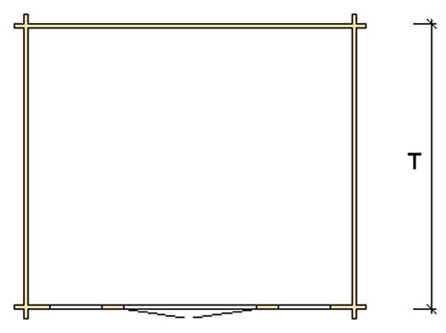
 | 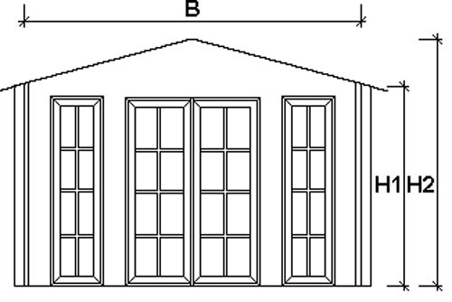

Nida Panorama Log Cabin
Roof projection: Front 0.70 m
Back 0.20 m
Side 0.30 m

Consists of:
Walls: 45 mm or (60 mm glued) double tongue and groove logs from Northern Pine
Floor: 20 mm tongue and groove floor boards on the impregnated base frame
Roof: 20 mm tongue and groove roof boards on the roof beams
Door: 1 glued cartridge door 140/196 with seal
Windows: 2 full length double-glazed 65/198 units

Size (m) |  | Price (£) |  | Optional Extras
 |  |  |  | Roof Insulation (£) |  | Shingles (£)
B | T | 45 | 60 | 45 | 60 | Shingles (£)
3 | 3 | 2479 | - | 90 | - | 121
3 | 4 | 2963 | - | 108 | - | 145
4 | 3 | 2963 | - | 108 | - | 145
4 | 4 | 3352 | 4006 | 130 | 132 | 145
4 | 5 | 3665 | 4334 | 147 | 149 | 218
5 | 4 | 3720 | 4399 | 152 | 154 | 218
5 | 5 | 4071 | 5280 | 172 | 173 | 250

Extras:

Single window £83
Double window 1200/940 £124

